CREDIT CARD DEFAULT

PREDICTION

# Wireframe Documentation

Lokendar Tirunahari

Once the app is opened web page displays the below shown home page:

All the information entered in this page is used for prediction.

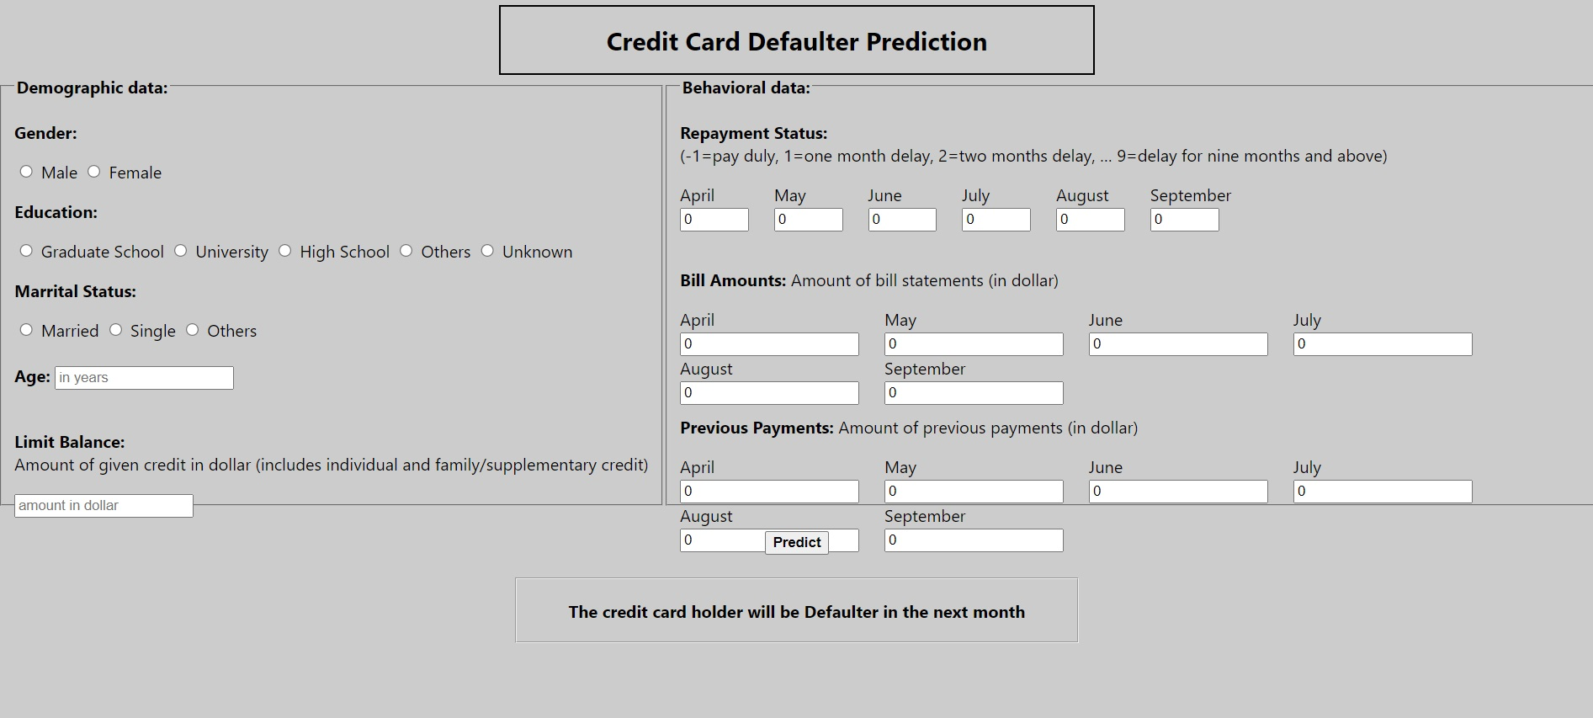

On left side of the page the demographic data of a user(gender, age, marital status, etc.) should be provided.

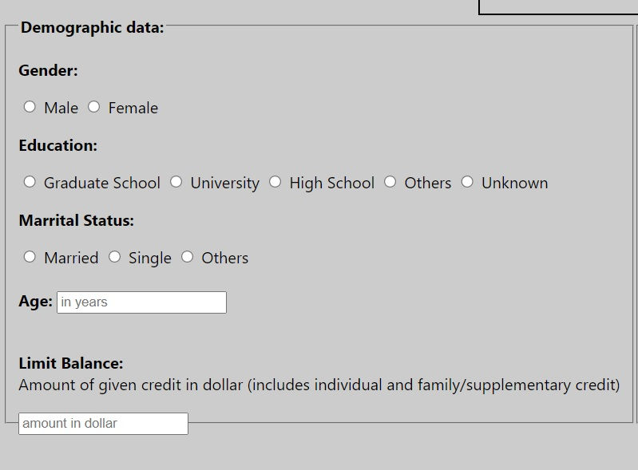

On the right-hand side other payment related details of the customer should be provided.

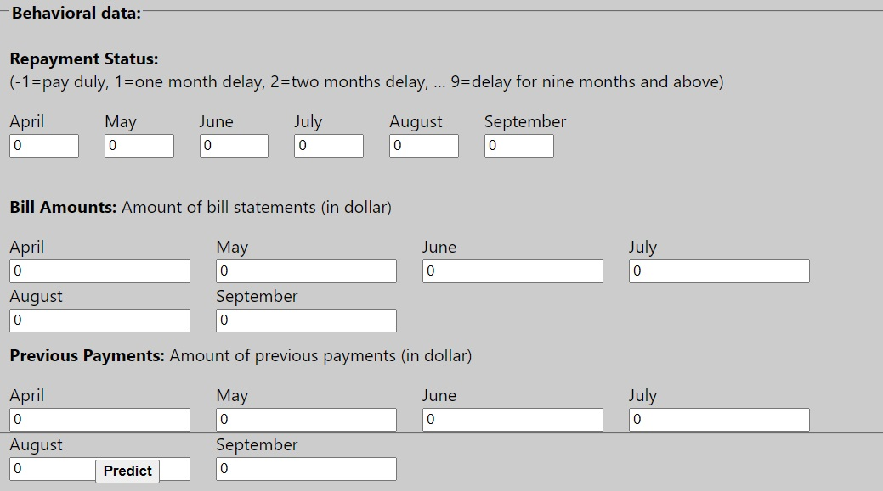

After providing all the details will get the prediction at the bottom of the page, i.e. if the borrower will be a defaulter or not.

